What to Bring:
- H20
- Ball cap with adjustable tab
- Boxing Gear
- Jump Rope
- Name Tag
- Mat-optional

October 2018

Mon | Tue | Wed | Thu | Fri | Sat
1  5:15 – 6:45pm  ALL LEVELS  Betsy | 2  Noon – 1:30pm PD 3/4 Betsy  1:45pm – 3:15pm PD 1/2 Betsy | 3 | 4  Noon – 1:30pm PD 3/4 Carol  1:45pm – 3:15pm PD 1/2 Carol | 5 | 6
8  5:15 – 6:45pm  ALL LEVELS  Betsy | 9  Noon – 1:30pm PD 3/4 Nic  1:45pm – 3:15pm PD 1/2 Nic | 10 | 11  Noon – 1:30pm PD 3/4 Carol  1:45pm – 3:15pm PD 1/2 Carol | 12 | 13
15  5:15 – 6:45pm  ALL LEVELS  Betsy | 16  Noon – 1:30pm PD 3/4 Nic  1:45pm – 3:15pm PD 1/2 Nic | 17 | 18  Noon – 1:30pm PD 3/4 Nic  1:45pm – 3:15pm PD 1/2 Nic | 19 | 20
22  5:15 – 6:45pm  ALL LEVELS  Nic | 23  Noon – 1:30pm PD 3/4 Carol  Snack&Share 1:30-2  2pm – 3:15pm PD 1/2 Carol | 24 | 25  Noon – 1:30pm PD 3/4 Nic  1:45pm – 3:15pm PD 1/2 Nic | 26 | 27
29  5:15 – 6:45pm  ALL LEVELS  Betsy | 30  Noon – 1:30pm PD 3/4 Nic  1:45 – 3:15pm  PD 1/2 Nic | 31

Reminder:
Snack&Share Tuesday 10/23 1:30-2

Prizes for BEST Halloween Costume!

PurEnergy Fitness Center
1905 Ashwood Ct.
Greensboro, NC 27455
336.282.4200www.julieluther.com

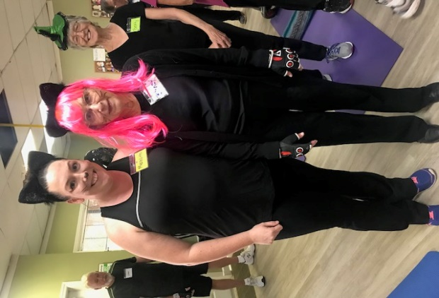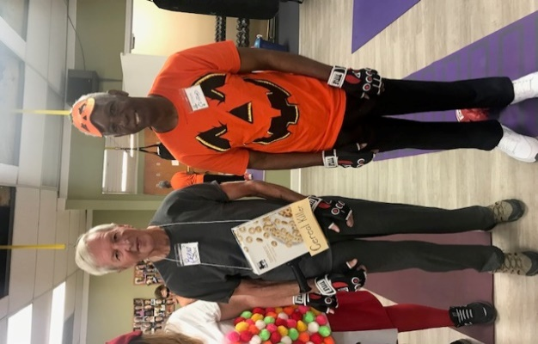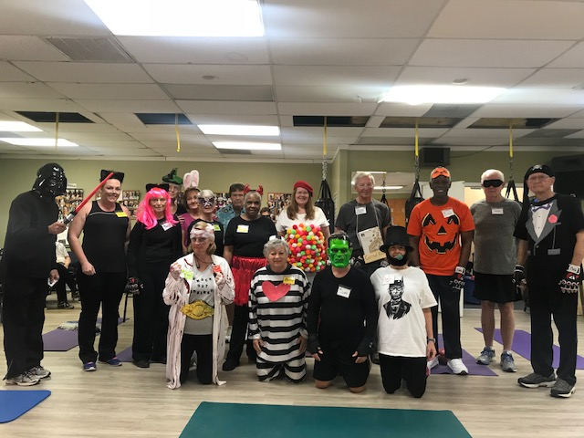

Follow Rock Steady on Social Media:
Facebook- Rock Steady Boxing / Rock Steady Boxing Greensboro
Instagram: rock_steady_boxing / purenergy_fitness_center

Monthly Power over Parkinson’s meeting:
Tuesday, October 16th, 4-5 pm
at Women’s Hospital Education Center
801 Green Valley Rd
Greensboro, NC

If you’re going to be gone for more than a week, please let your
Coach know.

Coach Carol: 336-707-0237 or cedmiston@triad.rr.com
Coach Nic: divo@divofitness.com
Coach Betsy: blerner55@gmail.com

