

**What to Bring:**

* **H20**
* **Ball cap with adjustable tab**
* **Boxing Gear**
* **Jump Rope**
* **Name Tag**
* **Mat-optional**

December 2019

|  |  |  |  |  |  |
| --- | --- | --- | --- | --- | --- |
| Mon | Tue | Wed | Thu | Fri | Sat |
| **2**  **5:15 – 6:45pm**  **ALL LEVELS**  Carol | **3**  *50’s Music*  **Noon – 1:30pm PD 3/4** Carol  **1:45pm – 3:15pm PD 1/2** Carol | **4** | **5**  **Noon – 1:30pm PD 3/4** Nic  **1:45pm – 3:15pm PD 1/2** Nic | **6**  Yoga  11:30-12:30  Nic | 7 |
| **9**  **5:15 – 6:45pm**  **ALL LEVELS**  Betsy | 10  **Noon – 1:30pm PD 3/4** Nic  **1:45pm – 3:15pm PD 1/2** Nic | **11** | **12**  **Noon – 1:30pm PD 3/4** Betsy  **1:45pm – 3:15pm PD 1/2** Betsy | **13** | 14 |
| **16**  **5:15 – 6:45pm**  **ALL LEVELS**  Betsy | 17  **Noon – 1:30pm PD 3/4** Carol  **1:45pm – 3:15pm**  **PD 1/2** Carol | **18** | **19**  *Holiday Fun*  **Noon – 1:30pm PD 3/4** Nic  **1:45pm – 3:15pm PD 1/2** Nic | **20**  Yoga  11:30-12:30  Carol | 21 |
| **23**  **5:15 – 6:45pm**  **ALL LEVELS**  Betsy | **24**  **CLOSED**  **CHRISTMAS EVE**  C:\Program Files (x86)\Microsoft Office\MEDIA\CAGCAT10\j0183290.wmf | **25**  **CLOSED**  **MERRY CHRISTMAS**  **C:\Users\PurEnergy User\AppData\Local\Microsoft\Windows\INetCache\IE\PT606X5Q\christmas-tree[1].png** | **26**  *Boxing Day*  **Noon – 1:30pm PD 3/4** Carol  **1:45pm – 3:15pm PD 1/2**  Carol | **27** | **28** |
| **30**  **5:15 – 6:45pm**  **ALL LEVELS**  Nic | 31  **Noon – 1:30pm**  **All Levels**  Carol |  |  |  |  |

**Weekly Focus:**

Week 1- Jab Cross

Week 2 – Hooks

Week 3- Upper Cuts

Week 4- Combos

**FUNdamental Punching Practice**

**All month long.**

**DON’T MISS A WEEK**

**PurEnergy Inclement Weather Policy**

Call 336.282.4200

If we are closed our message will reflect that

If we are open our regular message will play



**PurEnergy Fitness Center**

***Coach Carol: 336-707-0237 or*** [***cedmiston@triad.rr.com***](mailto:cedmiston@triad.rr.com)

***Coach Nic:*** [***divo@divofitness.com***](mailto:divo@divofitness.com)

**Coach *Betsy*:**[***blerner55@gmail.com***](mailto:blerner55@gmail.com)

1905 Ashwood Ct.

Greensboro, NC 27455

336.282.4200 www.julieluther.com





**Cheer Challenge:**

**Compose a cheer to share with the class**

**Shout out to Jim Dean for his original cheer:**

Pound that bag, slam down that ball  
Zip up your jacket and stand up tall  
These skills we’ve been taught,   
 But that’s not all  
At Rock Steady Boxing we practice how to fall  
Get back on our feet and punch “Parkie” in the jaw  
Fight back with Rock Steady!

**­­­­­­­­­­­­­­­­­­­­­­­­­­­­­­­­­­­­_________________________________________________­­­­­­­­­­__**

**Reminder:**

**Only 1 class on Tuesday, December 31st**

**(All Levels)**

**12-1:30pm**

**Welcome to our new Fighters!**

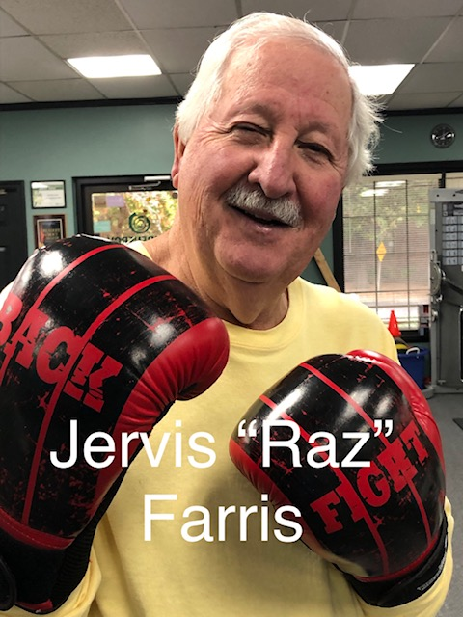

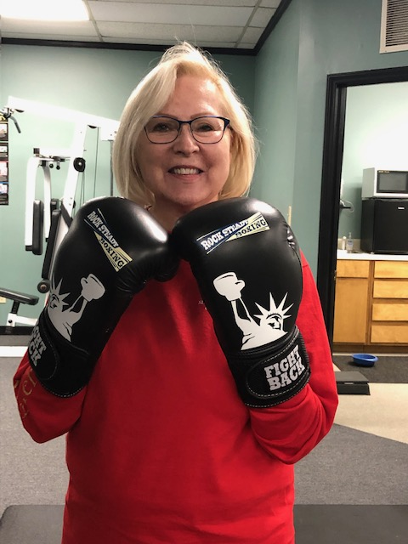

**Ginny “Gin-Gin”**

**Retallack**